BONNEVILLE DAM
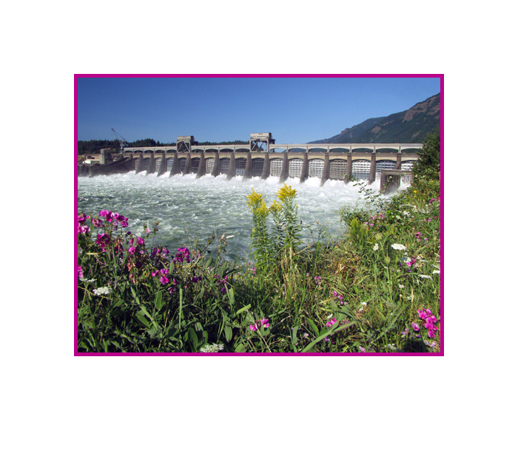

FISHWAY STATUS ANNUAL REPORT

2010

By

Ben J. Hausmann
Jonathan G. Rerecich
Kasey M. Welch
Andrew W. Traylor

U. S. Army Corps of Engineers
CENWP-OD-B
Bonneville Lock & Dam
Cascade Locks, OR 97014
(541) 374-4598

31 January 2011

TABLE OF CONTENTS
INTRODUCTION 2
Figure 1. Bonneville Lock and Dam. 2
FISHWAY OPERATION AND ACTIVITIES 3
Fish Passage Plan Violations 3
Table 1. Fish Passage Plan violations and percent in criteria. 3
STS/VBS Inspections 5
Table 2. STS and VBS Inspections 2009-2010 5
Zebra/Quagga Mussels 5
Avian Abatement Measures 5
Auxiliary Water System (AWS) Closures 6
Table 3. Fish Valve closures and closure times. 6
Fish counts 6
Fishway Temperature Monitoring 7
Figure 2. 2010 Bonneville Fishway temperatures. 7
FISH FACILITY AND TURBINE OUTAGES 8
Table 4. Fish Facility Outages of at least 12 hours. 8
Table 5. Fish Unit Outages and Reduced Loads. 8
Table 6. Turbine Outages of at least 24 hours. 9

FISH REMOVAL 10
Fishway Modifications (1996-Winter 2009/10) 11
GLOSSARY 14
References 15

INTRODUCTION
The 2010 Fishway Status Annual Report for Bonneville Lock and Dam summarizes activities impacting fish at Bonneville Project from 1 December 2009 through 30 November 2010.

Primarily a summary of weekly reports, this document summarizes all activities affecting fish passage including maintenance outages, dewaterings and recent modifications to fishway components. This document is required by the Corps of Engineers’ Northwestern Division, as described in the Fish Passage Plan (FPP). The FPP contains the following reporting requirements: “The (weekly) reports shall include: any out of criteria situations observed and subsequent corrective actions taken; equipment malfunctions, breakdowns or damage, along with a summary of resulting repair activities; adult fish control calibrations; STS and VBS inspection; any unusual activities which occurred at the project which may affect fish passage.” Project biologists perform inspections of the fish passage facilities three times per day and seven days per week during fish passage season and three times per day at least three times per week during winter maintenance season as outlined in the FPP.

The Project includes two powerhouses, a spillway and two navigation locks. The older of the two navigation locks has not operated since early 1993. There are four adult fish ladders for upstream migration located at each powerhouse and the north and south ends of the spillway. There are three Juvenile Bypass Systems (JBS) for downstream migration: an Ice and Trash Sluiceway (ITS) at Powerhouse 1 (PH1), a downstream migration transportation channel (DSM) at Powerhouse Two (PH2), and the corner collector at PH2 (B2CC).

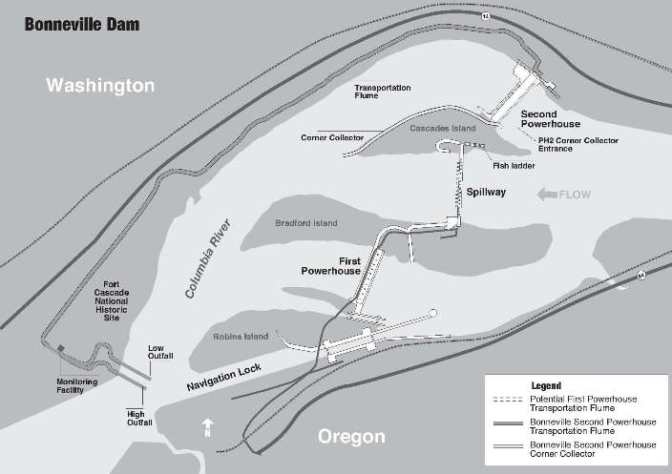Figure 1. Bonneville Lock and Dam.

FISHWAY OPERATION AND ACTIVITIES

Fish Passage Plan Violations
Project Fisheries and the control room operators conduct inspections each day during fish passage season, and at least 3 days per week during winter maintenance. The results of 320 daily fishway inspections, including 9 conducted by National Oceanic and Atmospheric Administration (NOAA) Fisheries, are shown in the following table. Listed are the FPP violations and the percentage of days the item was in criteria based on Project Biologist’s inspections only. Items in criteria 100% of the time are not listed.

Table 1. Fish Passage Plan violations and percent in criteria.
Out of criteria details
The following paragraphs are explanations for items (Table 1) that were out of criteria more than 90% of the reporting year.

At PH1, the velocity meter is placed in an eddy in the slowest part of the collection channel. Due to this placement, Project Fisheries used the mechanical velocity meter as the primary indicator of velocity. The mechanical meter was removed on 18 August for maintenance crews to use as a template while constructing a new one for PH2.

PH1 Collection Channel (CC) diffusers were out of criteria the entire fish passage season. FG 2-19 failed to open at water-up in 2006. The collection channel, however, remained within FPP criteria. The diffuser is scheduled to be repaired during the winter of 2011/2012.

The SA-24 board that controls the PH2 entrances (NUE, NDE, SUE, SDE) and adult ladder components is in need of replacement. A new programmable logic controller (PLC) system has been budgeted for. Because of this, all PH2 adult fishway entrances were operated manually the entire fish passage season.

The PH2 velocity meter was found to be reading incorrectly. The Project maintenance crews have constructed a new one that is scheduled to be installed during the 2010/2011 winter maintenance period.

The Cascades Island (CI) diffusers were operated with a different configuration than previously used due to the installation of the new entrance weir and its affects on ladder hydraulics. This was part of the CI entrance modification evaluation and is not considered out of criteria.

STS/VBS Inspections
Submersible traveling screens (STS) and vertical barrier screens (VBS) are inspected once a month. Each STS has a timer that automatically shows elapsed time of operation, with one month of continuous operation equaling 720 hours. Bonneville uses an underwater video camera to inspect STSs and VBSs. This gives the project the ability to inspect the screens while they are installed and while the unit is running, and has eliminated the need to dip gatewells. PH2 STSs are installed from the end of February until December 15 in operational units for juvenile fish passage and for adult fallbacks. PH1 screens have been permanently removed.

Table 2. STS and VBS Inspections 2009-2010

Zebra/Quagga Mussels
Through weekly inspections of the monitoring station at the PH1 and of all dewatered fishways, we have found no indication of zebra or quagga mussel colonization. It is widely believed that their arrival is inevitable. The Project stays involved in regional preparation for zebra/quagga mussel arrival by sending project personnel to training and seminars to stay abreast of the latest information concerning these invasive species. We continue monitoring with hopes that control programs can be initiated at the first indication of the mussel’s arrival in the Pacific Northwest.

Avian Abatement Measures
Avian lines are strung over the PH1 tailrace, spillway tailrace, PH2 tailrace, and over the B2CC plunge pool. 13 of the 20 PH1 avian wires were removed from 27 October until 18 November to facilitate the removal of the PH1 JBS outfall pipe. All other lines were intact during the fish passage season. USDA Wildlife Services avian hazing occurred from May through August. This was done from the tailrace side of the powerhouses, the spillway, and the shoreline.

Auxiliary Water System (AWS) Closures
The AWSs were closed on several occasions for varying reasons during the 2009-2010 reporting year. AWS valves were closed for winter maintenance, trashrack cleaning, and remote operated vehicle (ROV) fishway inspections. Trashracks are usually cleaned multiple times each month with more frequent cleanings during fall and winter season. Table 3 shows the number of closures and total closure time per fish valve.

Table 3. Fish Valve closures and closure times.

Fish counts
The Corps of Engineers contracts with Washington Department of Fish & Wildlife (WDFW) for all fish counting. The fish count season is year round with visual counts from March until November and video counts during the rest of the year. All fish count numbers may be found at: http://www.nwp.usace.army.mil/environment/fishdata.asp

Fishway Temperature Monitoring
Project biologists monitor fishway temperatures throughout the fish passage season, from March through November. The Adult Fish Facility (AFF) and Juvenile Monitoring Facility (JMF) are monitored primarily during the summer months when high temperatures can result in the need for sampling restrictions to minimize impact on fish passage. In 2010, temperatures were monitored from May through September. The following temperature charts illustrate daily average temperature trends. Detailed daily temperatures may be found in our weekly reports.

Bradford Island fishway temperatures are not available from 01 until 18 March due to issues with the temperature probe. From 27 June through 13 July, all four temperature probes were removed for maintenance.

Figure 2. 2010 Bonneville Fishway temperatures.

FISH FACILITY AND TURBINE OUTAGES

Table 4. Fish Facility Outages of at least 12 hours.

Table 5. Fish Unit Outages and Reduced Loads.

Fish units 1 and 2 were placed on standby at other times during the year to “float” trash away from the trash racks. When drawdown measured one foot or greater, fish units were shut down. An adjacent unit was then operated to pull trash away from the fish unit trashracks. This procedure helped prevent debris and silt from accumulating in front of the fish units. Most of the unit outages associated with the floating of trash and debris occurred between 2400 and 0300 to minimize impact on adult fish passage.

Table 6. Turbine Outages of at least 24 hours.

FISH REMOVAL

Fish passage facilities and turbine units are taken out of service and dewatered to allow for inspection, preventative maintenance, repairs, and modifications. As facilities and turbine units are dewatered, project biologists, outside agency personnel, and other project personnel follow procedures outlined in the FPP and detailed in the Fish Salvage Plan to minimize impacts on fish. Fish recovered are typically released into the forebay above the new navlock with the exception of sturgeon which are released below the dam at Hamilton Island. The following is a summary of the number of fish that were removed during facility and turbine unit dewaterings. All fish were recovered in good condition unless otherwise noted.

UMT (12/01/09): 12 steelhead, one juvenile chinook, one bass, several juvenile shad.

Bradford Island ladder (12/07/09): One unclipped adult steelhead, 13 clipped adult steelhead, 10 juvenile steelhead, 11 sturgeon, six lamprey, two crayfish, a couple hundred resident fish, 150 juvenile shad.

Bradford Island Junction Pool (12/07/09): 24 adult steelhead, one salmon, several peamouth, suckers and whitefish, 40 sturgeon, 15 juvenile shad. One dead adult steelhead in A-Branch.

A-branch (01/06/10): Two steelhead.

B-branch (01/11/10): Four steelhead and approx. 65 sturgeon.

B-branch (01/12/10): Approx. 180 sturgeon.

Unit 13 gatewells (05/03/10): Approx. 40 yearling Chinook. One yearling chinook mortality.

Unit 7 tail logs (05/11/10): One decayed adult chinook returned to the river.

Unit 18 gatewells (06/04/10): Several hundred yearling chinook and juvenile sockeye. Six mortalities were also recovered.

Unit 13 draft tube (06/14/10): One sturgeon, one juvenile salmonid.

Unit 0 draft tube (08/02/10): One adult lamprey released to forebay.

Unit 14 tail logs (08/17/10): Five sculpin.

Unit 13 tail logs (08/20/10): Three sculpin.

Unit 18 tail logs (09/02/10): Five sculpin, one peamouth, two bass, and one half of a sturgeon carcass.

Unit 12 gatewells (09/13/10): 75 juvenile shad.

Unit 12 draft tube (09/14/10): 50 sturgeon.

Unit 9 tail logs (09/16/10): One bluegill, one perch, 50 crawdads, and 20 sculpin.

Unit 2 draft tube (10/06/10): Two sturgeon.

Unit 0 tail logs (10/14/10): Five bass, two sculpin, and seven crawdads.

Adult Fish Facility – upper section/holding pool (10/27/10): 25 sturgeon and four steelhead.

Unit 2 tail logs (11/02/10): Four sturgeon and one bass.

Unit 2 tail logs (11/17/10): Five sturgeon, five sculpin, and one crawdad.

Adult Fish Facility – Lower ladder down to entrance bulkhead (11/18/10): Approx. 30 suckers, two peamouth, one common carp

Unit 2 tail logs (11/23/10): Three sturgeon and 10 sculpin.

Fishway Modifications (1996-Winter 2009/10)
POWERHOUSE ONE ADULT
2006-present. Sea lion exclusion devices (SLEDs) are installed at the fishway entrances to prevent sea lion access to the fish ladder.
2005/06. Bulkheads were installed in the orifice gate and telescoping gate slots. Gates were removed along with the associated electronic and mechanical equipment.
2005/06. Passive Integrated Transponder (PIT) tag detectors installed in four serpentine weirs in the Bradford Island fishway.
2004-present. Utilize ROVs for fishway inspections instead of divers.
2003/04. Installed new electronic velocity meter at the north end of the PH1CC. No longer used.
2002/03. PH1CC orifice gates and telescoping gates are closed and disabled. Studies indicated more fish exited these gates than entered. Weir gates were left in service.
2001/02. Extra orifices in the overflow weirs were filled with concrete.
2000/01. PIT tag detectors installed in four orifice weirs in A-branch and four orifice weirs in
B-branch.
1998/99. FG3-10 through 17 disabled and filled with concrete. FG3-14 (at the junction pool) covered with metal plates instead of concrete.

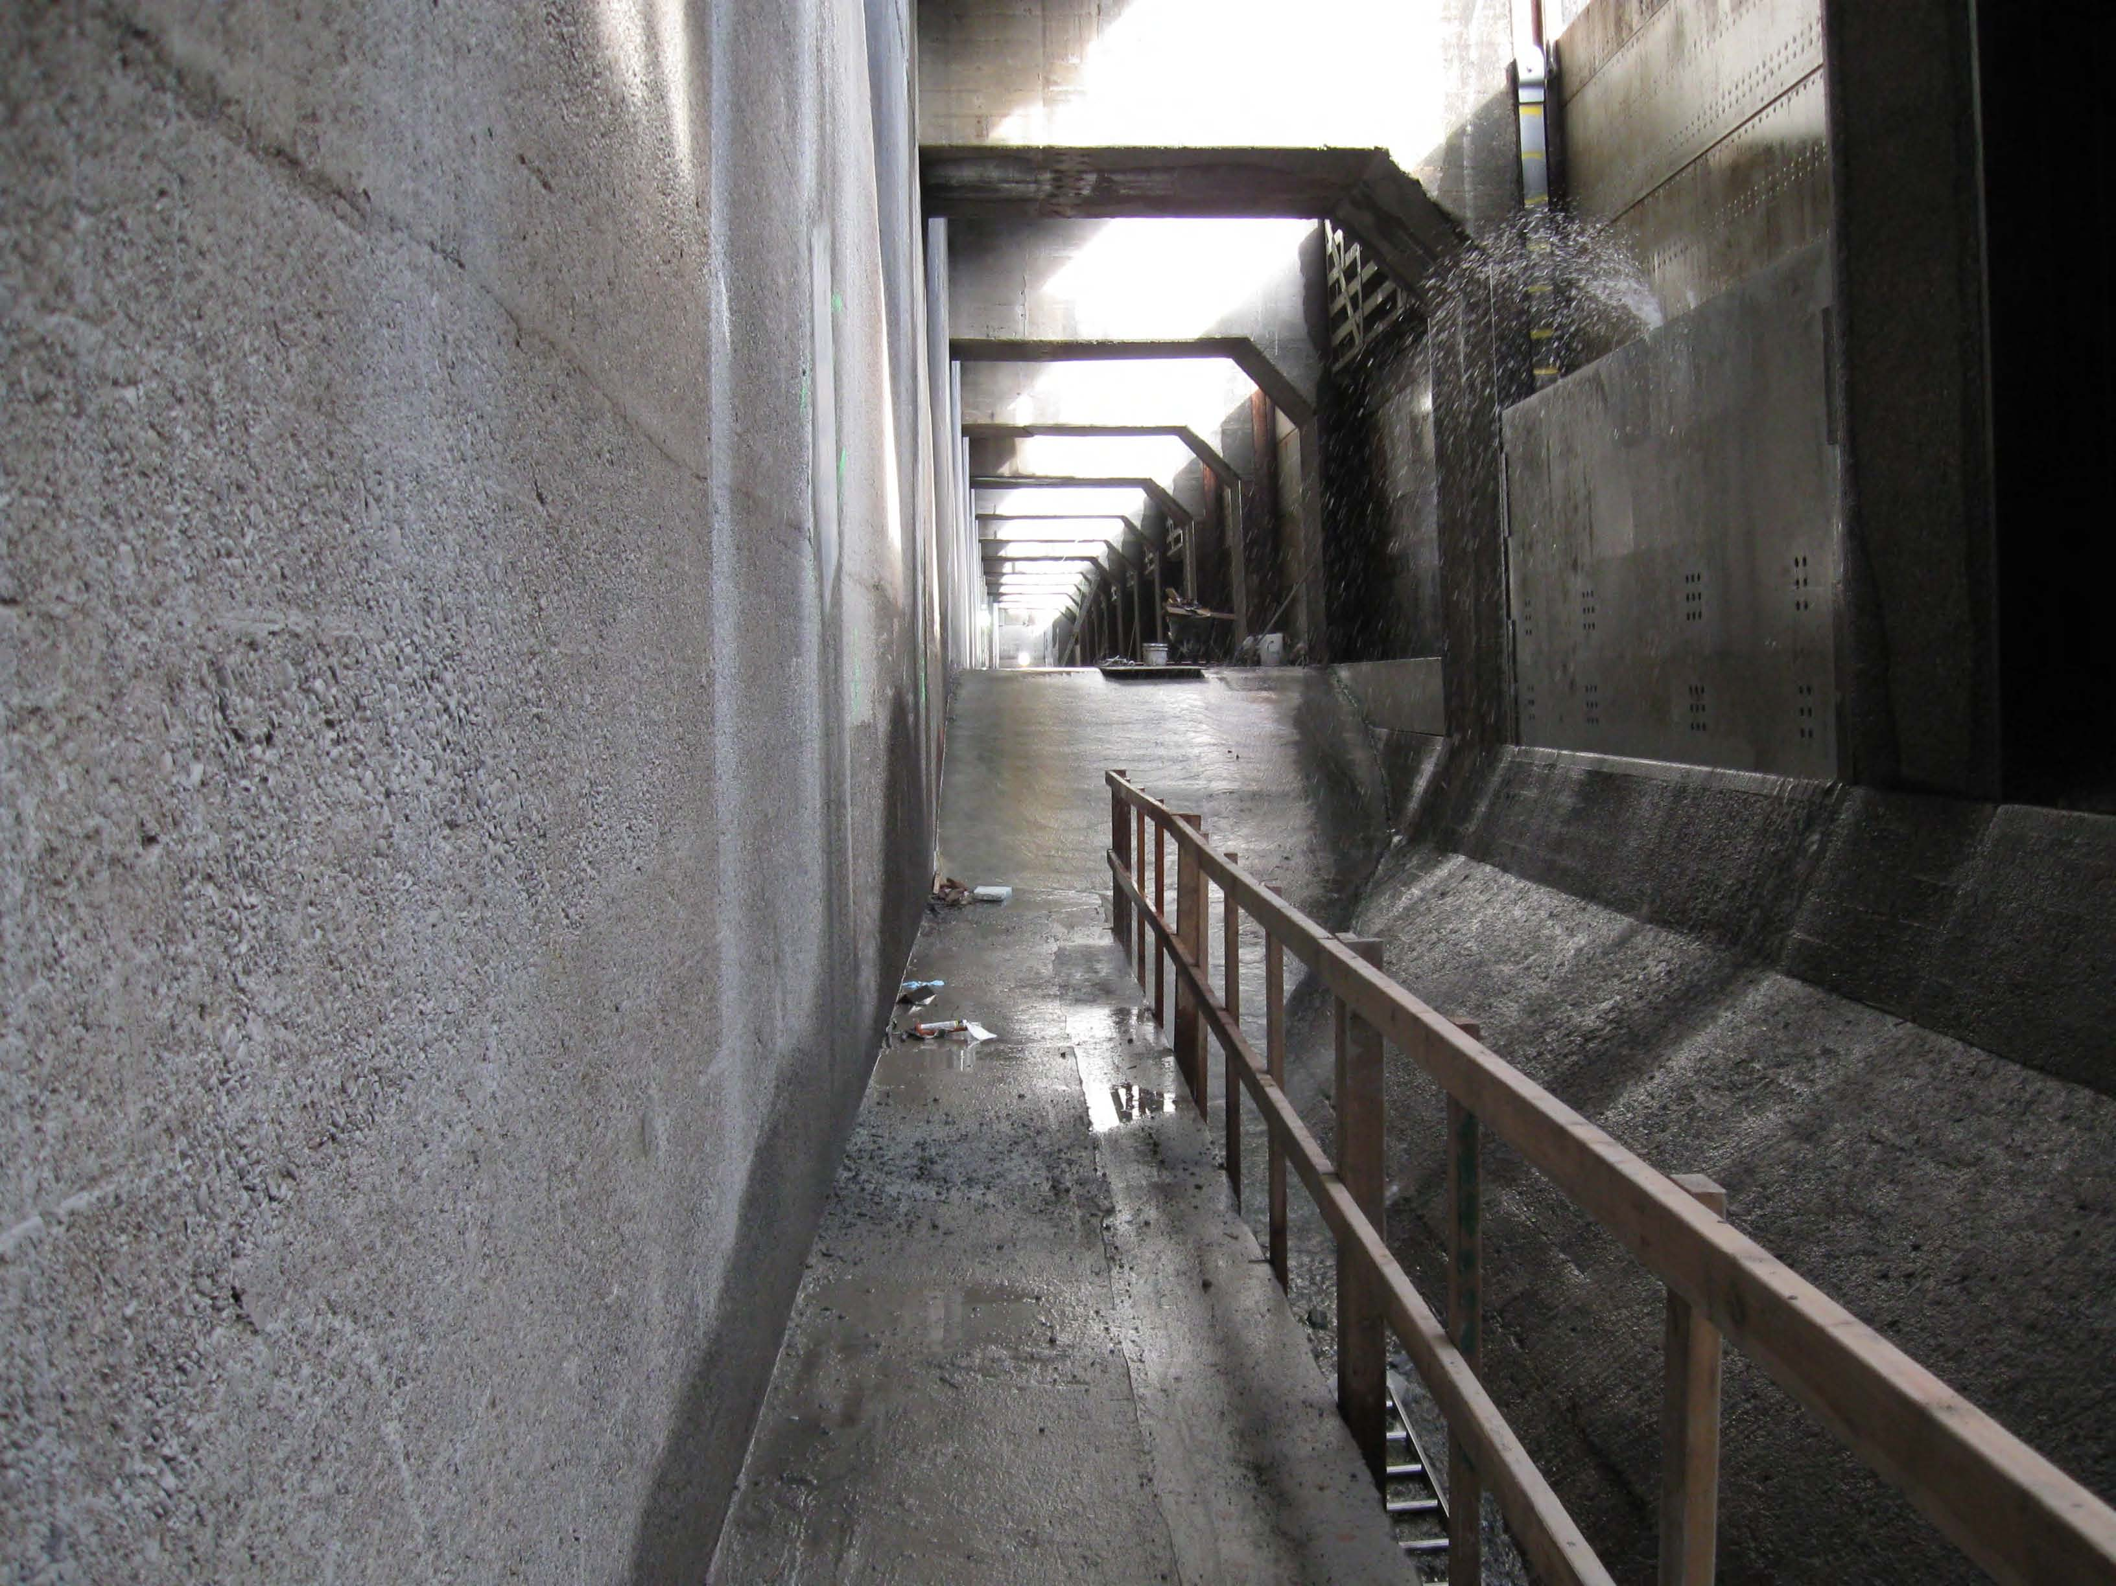
POWERHOUSE ONE JUVENILE
2010. PH1 JBS outfall pipe removed.
2009/10. Removal of the wall separating DSM1 from the ITS complete to improve surface passage at PH1. The floor was raised and sloped.
2009. All remaining PH1 screens scrapped.
2008/09. ITS automated chaingates installed in 3B, 6C, and 10B.
2004-2007. DSM1 is disabled as a juvenile bypass route. Screens are not installed during fish passage season except from 15 September until 15 December for adult fallback. DSM1 runs south during this time.
Completed Ice & Trash Sluiceway.
2001-2003. Unit 8 extended submerged bar screens were deemed undesirable and replaced with standard STSs.
2001-present. The 2000 Biological Opinion (BiOp) required the removal of impediments to fish passage from the turbine environments. Removal and replacement of excess metal, with fish friendly alternatives, occurs as units go out of service for rehab.
2000-2010. Turbine rehab involves installing minimum gap runners on all PH1 main units.

POWERHOUSE ONE LAMPREY
2005/06. PIT tag detection and expanded lamprey ramp installed in the Bradford Island FV3-9 AWS channel.
2003/04. Lamprey ramp installed in the Bradford Island FV3-9 AWS channel.

CASCADES ISLAND FISHWAY/ UMT
2004-present. Utilize ROVs for fishway inspections instead of divers.
2004/05. UMT fish count window crowder and window cleaner removed.
2001/02. New diffuser covers built and installed.
2000/01. More PIT tag detectors installed in four orifice weirs.
1999/00. FG6-1 through 4 filled in with concrete.
1998/99. PIT tag detectors installed in four orifice weirs.
1996-2000. The UMT drain is blind flanged and no longer used.

CASCADES ISLAND LAMPREY
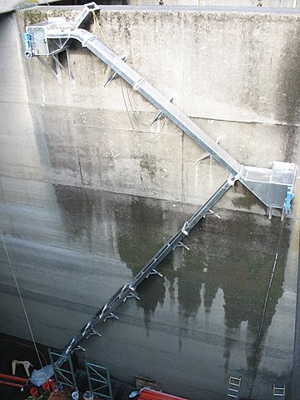
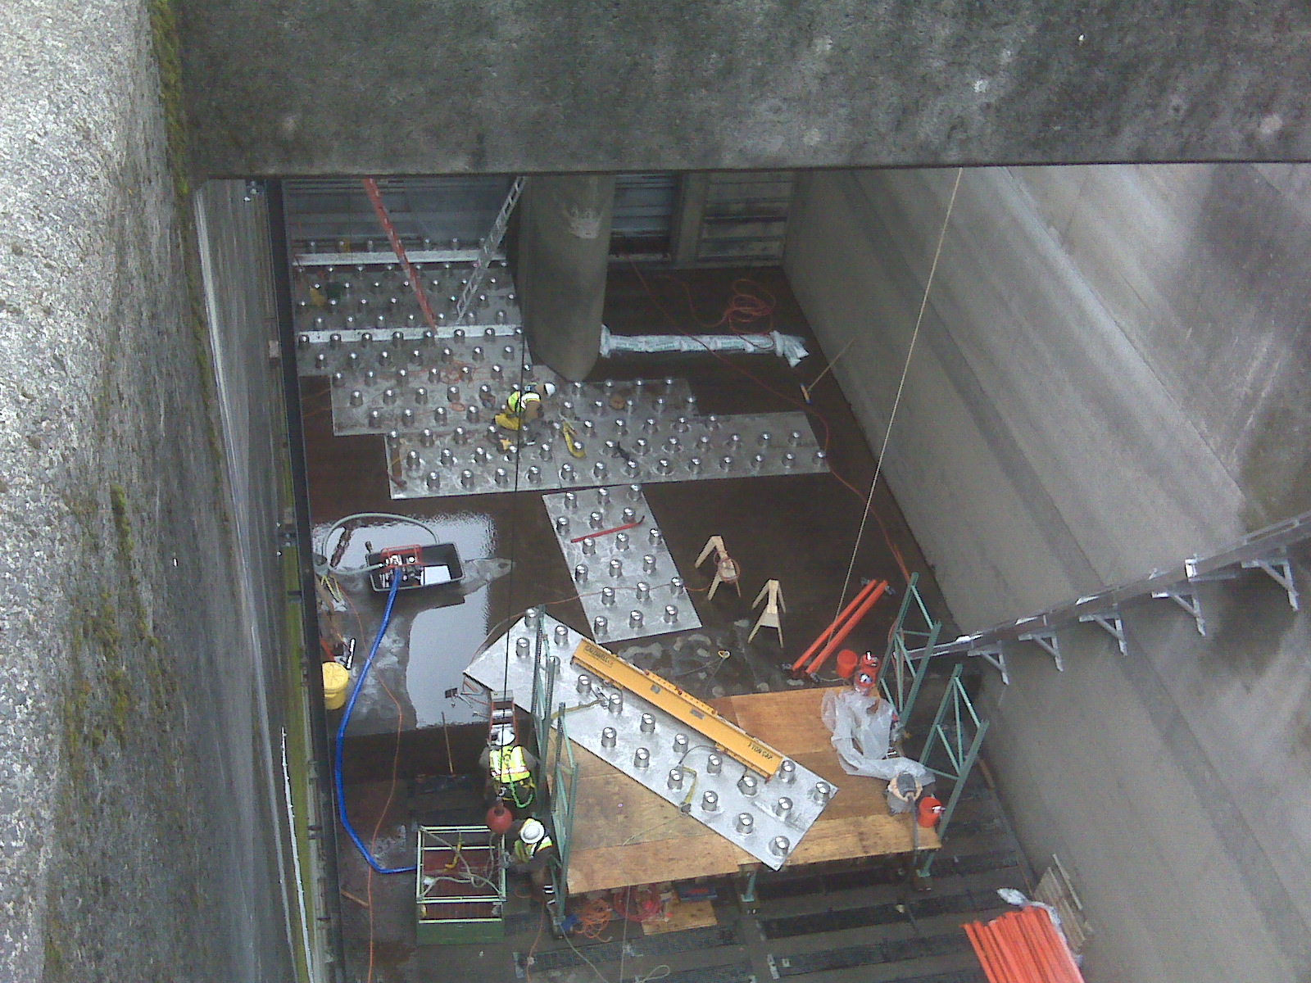
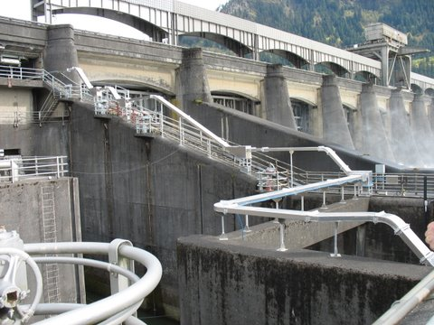
2008/09. Lamprey ramp and bollards installed in CI entrance pool. Variable width entrance weir installed in May.
2005/06. Half duplex PIT tag detectors were installed along the picket leads to track lamprey.
Cascades Island lamprey modifications.

POWERHOUSE TWO ADULT
2008/09 Picket leads installed perpendicular to existing AFF picket leads. Not used in 2010.
2007/08 Manufactured new FOG SLEDs.
2006/07. Installed new staff gauges in the monoliths.
2006/07. AFF lamprey orifice gate removed due to pulley failure resulting in salmon passage blockage and dewatering difficulties.
2005-present. SLEDs installed at fishway entrances to prevent sea lion access to the fish ladders.
2005/06. AFF count window crowder removed due to structural failure.
2004-present. Utilize ROVs for fishway inspections instead of divers.
2004/05. Repaired the AWS conduit.
2004/05. Installed new velocity meter at South Upstream Entrance (SUE).
AFF picket leads.
2004/05. PIT tag detectors installed in four serpentine weirs.
2004/05. AFF brail pool modifications made. The brail pool is now the primary recovery pool.
2003/04. AFF electrical upgrades complete.
2003/04. Picket leads for the triangle section were removed.
2002/03. Removed old metal staff gauge frames from monolith entrances.
2001/02. PIT tag detectors installed in eight orifice weirs, four upstream and four downstream of the AFF.
1999/00. AFF exit ladder equipped with orifice PIT tag detectors.

POWERHOUSE TWO JUVENILE
2008/09. Release pipe attached to JMF outfall pipe for juveniles trucked from Walla Walla District.
2007/08. Behavioral Guidance Structure (BGS) installed in PH2 forebay. Removed in December 2010.
2007/08. PH2 Downstream Migrant transportation channel (DSM2) LED lights returned to halogen lights due to the unknown effects of LEDs.
2007/08. Units 14 and 18 are modified for new VBSs and improved FGE.
2006/07. New LED lights replace the halogen lights. The LED lights are cooler and will last years longer than the halogens. These lights were salvaged from DSM1.
2006/07. Units 11, 15, 16 are modified for new VBSs and improved FGE.
2005/06. B2CC PIT tag antenna installed.
2005/06. SMF full flow PIT tag antenna installed.
2005/06. Units 12 and 13 modified for new VBSs and improved Fish Guidance Efficiency (FGE).
2004/05. VBS modifications for Unit 17 result in screen failure. The design for the new VBSs is re-examined and redrawn.
2004/05. SMF Outfall hydrocannon piping is replaced.
2004/05. B2CC complete and online.
2003/04. Unit 17 VBSs and gatewells are modified to improve FGE. Modifications include gap closure devices on the STSs and modified VBSs.
2002/03. NOAA Fisheries fyke net frame is removed from the tailrace.
2002/03. Unit 15 gatewells are partially modified to improve FGE. Modifications include gap closure devices on the STSs.
2002/03. Biologists noticed places of ovality while inspecting the two mile pipe. The pipe has been monitored regularly to document potential changes.
2002-present. The 2000 BiOp required the removal of impediments to fish passage from the turbine environments. Removal and replacement of excess metal, with fish friendly alternatives, occurs as units come out of service for maintenance.
2001/02. Raised the DSM2 walkway grating to prevent fish from impacting it.
2001/02. Modified the DSM2 add-in screen to vertical bars to allow juveniles to move out of the add-in water and into the channel. The bars didn’t reach the walkway so a perforated plate was added later in the season to prevent adults from jumping into the add-in section.
2001/02. Flume covers were added over the switchgates. This was to encourage fish to stay in the main channel and not seek shade by swimming under the switchgates.
2000/01. Saltwater rearing moved into the SMF.
2000/01. Modifications were made to the primary dewatering structure drain pipe to divert more water into the wetlands. This reduced the flow fluctuations and air bubbles under the perforated plate in the primary dewatering structure.
1998-2000. SMF construction completed. The facility goes online.

POWERHOUSE TWO LAMPREY
2010. Picket lead spacers installed to allow lamprey passage under leads
2007/08. Lamprey ramp installed in the Washington Shore FV6-9 AWS channel.
2004/05. Lamprey ramp installed at North Downstream Entrance (NDE).
2000/01. Lamprey plates are installed over the Washington Shore diffuser grates.

BASS LAKE
2006. The leaking drain is repaired. The lake holds water and coho are seen spawning in the outlet (Moffett Creek) of Bass Lake. The salvaged logs create log jams over the sink hole.
2004. Salvaged logs are placed in Bass Lake to provide habitat.
GLOSSARY

AFF----- Adult Fish Facility. Lab associated with the Washington Shore ladder. Adult fish are trapped for research purposes.
AWS-------------------------Auxiliary Water Supply.
B2CC------------------------Powerhouse Two Corner Collector. A surface bypass system located in the southern corner of the Bonneville Second Powerhouse forebay.
BGS--------------------------Behavioral Guidance Structure. Located in the PH2 forebay.
BI--- Bradford Island Fishway.
BiOp Biological Opinion.
BPA---------------------------Bonneville Power Association.
CI-- Cascades Island Fishway.
Collection Channel(CC) Part of the adult fishway spanning the length of the downstream side of each powerhouse.
DSM1 Downstream Migrant transportation channel (PH1). Transport channel for adult fallback and steelhead kelts from gatewell orifices to the ice and trash sluiceway.
DSM2 Downstream Migrant transportation channel (PH2). Transport channel for juvenile fish from gatewell orifices to the juvenile transport pipe.
FG Fish diffusion gate.
FGE--------------------------Fish Guidance Efficiency.
FOG Floating Orifice Gate.
Forebay That area of a reservoir immediately upstream of a dam.
FPP Fish Passage Plan.
FV Fish Valve.
ITS Ice and Trash Sluiceway.
JBS Juvenile Fish Bypass System.
JMF--------------------------Juvenile Monitoring Facility. Lab associated with the PH2 JBS.
NDE----- North Downstream Entrance. Refers to one of the four large overflow weir adult fishway entrances at PH2.
NUE North Upstream Entrance. See NDE.
NOAA National Oceanic and Atmospheric Administration.
OOS Out of Service.
PH1 Bonneville Powerhouse One.
PH2 Bonneville Powerhouse Two.
PIT ------ Passive Integrated Transponder. A tag inserted into juvenile and adult fish. Detectors are installed at all fish passage systems.
Project Bonneville Lock & Dam.
ROV--------------------------Remotely Operated Vehicle.
SDE South Downstream Entrance. See NDE.
SLED Sea Lion Exclusion Device
SUE South Upstream Entrance. See NDE.
STS Submersible Traveling Screen.
Tailrace The portion of a river immediately downstream of a dam or powerhouse.
TDG---------------------------Total dissolved gas.
UMT----- Upstream Migrant Transportation channel. This channel connects Cascades Island ladder to Washington Shore ladder through PH2.
VBS Vertical Barrier Screen.
WDFW Washington Department of Fish & Wildlife.

References

2009. Fish Passage Plan for Corps of Engineers Projects. U. S. Army Corps of Engineers, Northwestern Division, Portland, Oregon.

2010. Fish Passage Plan for Corps of Engineers Projects. U. S. Army Corps of Engineers, Northwestern Division, Portland, Oregon.

2009-2010. Weekly reports for Bonneville Dam. U.S. Army Corps of Engineers, Portland District. Bonneville Lock and Dam.

2009-2010. Daily fishway inspections for Bonneville Dam.

